Cache Documentation

Authors: Nikodem Gazda, Luke Saleh, Brennan Borchert, Quinlan Stewart

Table of Contents

2 General Implementation 2

2.1 Cache Operations 2

2.1.1 Read Hit 2

2.1.2 Read Miss 2

2.1.3 Write Hit 2

2.1.4 Write Miss 2

2.2 Simulation Results 2

3 Individual Components 2

3.1 Cache Block 2

3.1.1 Functionality 2

3.1.2 Simulation Results 2

3.1.3 Sub-component: Cache Data 2

3.1.4 Sub-component: Cache Tags 4

3.1.5 Sub-component: Cache Valid Bits 7

3.1.6 Sub-component: Cache Hit Logic 9

3.1.7 Sub-component: Cache LRU Buffer 11

3.1.8 Sub-component: Cache Control 13

3.2 Ram Block 13

3.2.1 Functionality 13

3.2.2 Simulation Results 13

3.3 Miscellaneous Logic 15

3.3.1 Register 15

3.3.2 Delay 16

4 Conclusion 17

# General Implementation

## Cache Operations

### Read Hit

### Read Miss

### Write Hit

### Write Miss

## Simulation Results

# Individual Components

## Cache Block

### Sub-component: Cache Data

#### Functionality

The Cache Data block is the physical storage for data within the cache. The data is organized into multiple ways (configurable at compile time) and the input index is used as the cache address, whose size is the number of ways specified in the cache multiplied by the number of index addresses.

The inputs for this block are the write enable, the desired way to access, the cache index, the data input, and the only output is the data output. Reads from this block are combinational/instant while the writes sequential and take 1 cycle to update.

The memory locations in the Cache Data block must be indexed with both the desired way and the index. For example, if you would like to read from bank 2 in address 0x3, you must specify 2 as the desired way and 0x2 as the desired index.

#### Simulation Results

The Cache Data testbench consists of a set of direct testcases and random testcases.

**Directed Testcases:**

In the directed testcases, we increment the data value of each bank of each index, set the write enable to 1, and wait for the rising edge of the clock (ex. bank 1 of index 2 would have a value of index*number of banks + current bank = 9). We do this for every index and bank in the Cache Data block. The testbench itself has a reference model that mimics the behavior of the Cache Data block in an array. After all addresses have been written, we then read from every index/bank pair and compare with the data saved in the same addresses of the reference model. This testcase ensures that data that is written to the Cache Data block is maintained over longer periods of time, even as other indices and banks are written to and read from. See the figure below to see the first 5 values written to and read from the Cache Data block.

**Figure X:** Directed tests for the Cache Data block.

**Random Testcases:**

We performed 1000 random test cases with the following constrained random verification:

* Data input is all 0s 10% of the time, all 1s 10% of the time, and the rest of the values the other 80% of the time.
* Index input follows the same constraints as the data inputs.
* Way input is kept random.
* The write enable is asserted 50% of the time for 50% reads and 50% writes.
* Writes are followed by reads which must use the same index and way used for the write so that each write to a random address is checked.

**Figure X:** First 5 random testcases for the Cache Data block.

In this testcase, we can see that a read from bank 1 of index 1 returns 5, which is the value that was written to that address in the directed testcase. The next operation is a write to bank 2 of index 1, and we can see the read from this index/bank pair in the next cycle return that value of 253. The remainder of the random testcases passed with no failures.

**Assertions:**

* **out_correct_check:** This assertion checks the data output is always equal to the contents of the reference model. This is an immediate assertion since reads from the cache data block are combinational/instant.
* **write_check:** When the write enable is de-asserted, the write enable on the previous cycle was asserted, the index on this cycle matches the index from the previous cycle, and the way on this cycle matches the way from the previous cycle, then within the same cycle we expect that the data output is equal to the input from the previous cycle.

### Sub-component: Cache Tags

#### Functionality

The Cache Tags block is similar to the Cache Data block in that it acts as the physical storage for the tags in the cache, organized into banks and indices in the same way, with reads being combinational/instant and writes being synchronous as well.

The inputs for this block are the write enable, the desired way to access, the cache index, the target tag input, and instead of outputting the tag from just one bank, each bank from each index is output. This parallel output exists so it’s easier for the Cache Hit Logic block to determine whether there’s been a hit/miss. Reads from this block are combinational/instant while the writes sequential and take 1 cycle to update.

#### Simulation Results

The Cache Tag testbench consists of a set of direct testcases and random testcases and is very similar to the Cache Data testbench.

**Directed Testcases:**

The directed testcases for the Cache Tag block are the same, except that the printed outputs are each bank of the index. The following paragraph can be skipped if you’ve already read about the Cache Data testcase.

In the directed testcases, we increment the data value of each bank of each index, set the write enable to 1, and wait for the rising edge of the clock (ex. bank 1 of index 2 would have a value of index*number of banks + current bank = 9). We do this for every index and bank in the Cache Tag block. The testbench itself has a reference model that mimics the behavior of the Cache Tag block in an array. After all addresses have been written, we then read from every index/bank pair and compare with the data saved in the same addresses of the reference model. This testcase ensures that data that is written to the Cache Tag block is maintained over longer periods of time, even as other indices and banks are written to and read from. See the figure below to see the first couple values written to and read from the Cache Tag block.

**Figure X:** Directed tests for the Cache Tag block.

**Random Testcases:**

We performed 1000 random test cases with the following constrained random verification. If you’ve read the CRV for Cache Data, you can assume the same restrictions:

* Tag input is all 0s 10% of the time, all 1s 10% of the time, and the rest of the values the other 80% of the time.
* Index input follows the same constraints as the data inputs.
* Way input is kept random.
* The write enable is asserted 50% of the time for 50% reads and 50% writes.
* Writes are followed by reads which must use the same index and way used for the write so that each write to a random address is checked.

**Figure X:** First 5 random testcases for the Cache Tag block.

In this testcase, we can see a write of tag 118 to bank 1 of index 1. In the next testcase, we read from index 1 and see all the values stayed the same from the directed testcase except for bank 1, which has changed to the input tag of 118 from the previous write. The same happens in the next random write/read pair with a value of 61 in bank 2 of index 0. The remainder of the random testcases passed with no failures.

**Assertions:**

* **These assertions are the same as the ones from Data Cache, adjusted for the tags and the full index outputs.**
* **out_correct_check:** This assertion checks the tag output is always equal to the contents of the reference model. This is an immediate assertion since reads from the cache tag block are combinational/instant.
* **write_check:** When the write enable is de-asserted, the write enable on the previous cycle was asserted, the index on this cycle matches the index from the previous cycle, and the way on this cycle matches the way from the previous cycle, then within the same cycle we expect that the tag output of the specified way is equal to the input from the previous cycle.

### Sub-component: Cache Valid Bits

#### Functionality

The Cache Valid Bits block is similar to the Data and Tag blocks in that reads are combinational while writes take one cycle, however, the data stored in this block is 1 bit for each bank for each index. When the write enable is asserted, a 1 is written to the specified bank/index each time, since a first time write to each location would cause that address to become valid, and replacing any address would cause it to become valid for the new address. The valid bits are only cleared when reset is asserted.

The inputs for this block are the write enable, the desired way to access, the cache index, and the valid bit from each bank of the specified index is the output. This parallel output exists so it’s easier for the Cache Hit Logic block to determine whether there’s been a hit/miss.

#### Simulation Results

The Cache Valid testbench consists of a set of direct testcases and random testcases and is very similar to the Cache Tag testbench.

**Directed Testcases:**

The directed testcases for the Cache Valid block are the same except that each bank output has a width of only 1.

In the directed testcases, set the write enable to 1 and wait for the rising edge of the clock for every index and bank in the Cache Valid block. The testbench itself has a reference model that mimics the behavior of the Cache Valid block in an array. After all addresses have been written, we then read from every index/bank pair and compare with the data saved in the same addresses of the reference model. This testcase ensures that data that is written to the Cache Valid block is maintained over longer periods of time, even as other indices and banks are written to and read from. See the figure below to see the first couple values written to and read from the Cache Valid block.

**Figure X:** Directed tests for the Cache Valid block.

**Random Testcases:**

We performed 1000 random test cases with the following constrained random verification. These slightly differ from the Cache Tag in that the reset signal is randomized as well.

* Index input is all 0s 10% of the time, all 1s 10% of the time, and the rest of the values the other 80% of the time.
* Way input is kept random.
* The write enable is asserted 50% of the time for 50% reads and 50% writes.
* The reset signal is asserted 5% of the time so that the block’s contents are cleared occasionally.
* Writes are followed by reads which must use the same index and way used for the write so that each write to a random address is checked.

**Figure X:** First 5 random testcases for the Cache Valid block.

These first 5 testcases aren’t very telling since only a 1 can be written in each entry, but it does let us know that 1 is retained in the block for each index referenced. At points in the testbench, reset is asserted as well, clearing the contents of the cache and allowing for more variability.

**Assertions:**

* **out_correct_check:** This assertion checks the valid bit output is always equal to the contents of the reference model on all falling edges

### Sub-component: Cache Hit Logic

#### Functionality

The Cache Hit Logic block handles the logic for determining whether the incoming address is in the cache, whether it be for a read or write. This block is completely combinational.

The inputs are the target way, the full output of all the tags from the Cache Tag block, the full output of all the valid bits from the Cache Valid block, and the output of the LRU buffer in case of a miss.

The output is a bit labeled hit; when asserted, the Cache Hit Logic block is reporting a hit, and when not asserted, the logic block is reporting a miss. When there is a hit, the block also outputs the bank that corresponds to the matched tag/valid bit. When there is a miss, the block outputs the bank the LRU reports as the least recently used bank for the current index.

#### Simulation Results

The Cache Hit Logic testbench consists of a set of direct testcases and random testcases.

**Directed Testcases:**

There are 6 unique directed testcases for the Cache Hit Logic block, each repeated 5 times in our testing:

**Test 1:** all tags are 0, 1, 2, 3, target tag is 0, valid bits are 0, lru_way is 0

This is a test case where all inputs are 0 which should return a **miss**, since all the valid bits are 0, and the output **chosen way should be 0**, since the lru_way is 0.

**Test 2:** all tags are 0, 1, 2, 3, target tag is 0, valid bits are 0, lru way is 1

This is the same test as before with the only change being in the lru_way from 0🡪1. This should return a **miss** as well and the output **chosen way should be 1** to reflect that the output chosen way reflects the LRU way on a miss.

**Test 3:** all tags are 0, 1, 2, 3, targt tag is 0, valid bits are 1, lru way is 2

This test should return a **hit**, since all the valid bits are asserted and there exists a tag that matches the target tag, and the **output chosen way should be 0**, since that’s the location of the tag that matches. Note that the output chosen way should not reflect the LRU way.

**Test 4:** all tags are 0, 1, 2, 3, targt tag is 1, valid bits are 1, lru way is 3

This test is the same as the previous with the only changes being in the target_tag: 0🡪1, and the lru_way: 2🡪3. This test should return a **hit** and the **output chosen way should be 1**. The output chosen way should not reflect the LRU way in this test case either.

**Test 5:** all inputs are 0s

This testcase is similar to Test 1 except that all input tags are 0. This case should only ever be true in the beginning of operation when no cache entries have been written to yet, and it should return a **miss** and the **output chosen way should be 0**, reflecting the LRU way.

**Test 6:** all inputs are 1s

This scenario should never happen in the actual use of the cache since the tags should never be the same in the banks of one index. Either way, we should expect a return of a **hit** and the output **chosen way should be 3**, since the Cache Hit Logic block checks each tag incrementally.

All expected outputs match the true outputs, as seen below:

Figure X: Directed tests for Cache Hit Logic block.

**Random Testcases:**

We performed 100 random testcases (timed out with any more, limitation of EDA playground) with the following constrained random verification:

* **target_tag_ranges, lru_way_ranges, tags_ranges:** make sure target tag, lru way, and tags are ‘0 10% of the time, ‘1 10% of the time, and the rest of the range 80% of the time. Since the tag input is an array, each tag is assigned independently of the others.
* **tags_never_same:** This constraint prevents any of the tags from being equal to the others. In the operation of the cache, the tag inputs should never be the same unless in the first couple reads/writes where the valid bits are low, since a read/write to an address with the same tag would only alter that address. This edge case is covered in the multiple iterations of the directed testcases, therefore, we prevent this behavior here.
* **target_tag_match:** We want to test an even split of hits and misses, therefore, we need to ensure that one of the tags matches the target tag 50% of the time. To do this, we must randomize three integers before any of the DUT signals; one to get the 50/50 chance of deciding to force a match between one of the tags and the target tag, the second to randomly choose which tag to force, and the third to get a 50% chance of that valid bit being asserted so we have an even number of hits and misses when the tags match. These random variables are solved before the DUT’s signals.

**Figure X:** Randomized tests for Cache Hit Logic block.

As you can see in the randomized tests, in Test 1, no tag matches the target tag, therefore the output is a miss and the chosen way matches the lru_way. In test 2, bank 3 matches the target tag, and the corresponding valid bit is high, meaning the output is a hit and the chosen way is bank 3. Test 3 has the same behavior as test 1. Test 4 shows a tag match with bank 0, but the corresponding valid bit is 0, resulting in a miss with the chosen way reflecting the lru_way. Test 5 follows the same behavior as with tests 1 and 3.

The bottom output reports the number of tests, failures, and tag matches. This is meant to show that the CRV is constraining the inputs how we expect it to, with about a 50% chance of tags matching the target tag.

**Assertions:**

* **Miss_check:** If a miss is reported, the chosen way must match the lru way.
* **Hit_check:** If a hit is reported, the tag corresponding to the chosen way must match the target tag.
* **Tags_match:** If any of the tags match the target tag, there should be a hit reported. This is kinda a duplicate of the hit_check but I just wanted to make sure.
* **No_tags_match:** When no tags match the target tag, we expect a miss.

### Sub-component: Cache LRU Buffer

The Cache LRU Buffer stores the pointers to the least recently used banks for each index. The reads from the buffer are combinational and the buffer updates are synchronous, taking 1 cycle to update. The buffer considers any read or write to the cache as an update to itself.

The inputs for the LRU buffer are the read enable, the write enable, the chosen way that’s output from the cache hit logic, and the index input into the cache. The only output is the replacement way that’s used as an input into the hit logic block whenever a miss is detected.

#### Functionality

The LRU Buffer has a slot for each bank for each index which points to the least recently used bank. The leftmost slot in the buffer always represents the least recently used bank/way, last_used[0][index], and the rightmost slot always represents the most recently used bank/way, last_used[NUMBER_OF_BANKS][index]. When an update to the buffer is issued, the last slot in the buffer is assigned the chosen way on the input, indicating it is now the most recently used, and the rest of the slots in the buffer update accordingly. Below is a figure demonstrating this behavior:

**Figure X:** How the LRU Buffer works.

In this diagram, Bank 0 stays in the least recently used position. The chosen way moves into the slot of the most recently used position, and the rest of the banks move up the chain.

The LRU Buffer has a combinational portion and a synchronous portion:

In the combinational portion, we aim to find the slot in the buffer that corresponds to the chosen way input into the buffer. Each slot in the buffer for the current index is compared to the input way and the matching slot is assigned to a signal called current_way_addr, representing the slot we want to use to update the buffer. This can be seen in 1. and 2. of Figure X.

In the synchronous portion, if the buffer is to be updated on a read/write, we loop through each slot starting at the current_way_addr and ending one slot before the last slot (most recently used slot). Then, the last slot representing the most recently used bank is assigned the value in the slot of the current chosen way. This can be seen in 3. and 4. of Figure X.  
Since the least recently used bank is always held in the leftmost slot, it can be treated as asynchronous/combinational and always be output.

#### Simulation Results

The Cache LRU Buffer testbench consists of a set of direct testcases and random testcases. We use a reference model and probes into the design to verify the LRU buffer. The reference model is an array of integers with as many elements as there are in the buffer for each index. Each element serves as a counter, and on each buffer update, the corresponding slot is update with the simulation time. Whenever we want to check for the correct output, we can check the least recently used bank in the DUT matches the timer with the simulation time earliest in the simulation.

This method was not used in the design since timers can overflow and having a timer for each bank of each index would not be an efficient use of resources in the design.

**Sequential Directed Testcases:**

In addition to the directed testcases below, we also added sequential testcases which loop through each bank of each index and write. This effectively rotates the LRU buffer, as you can see below.

In the following figure, we are first shown the state of the buffer when the directed tests start. Then, we are shown the signal values (both inputs and outputs) as well as the state of the LRU buffer after the clock edge had passed for the first sequential test. This then repeats for each sequential test.

In the first sequential test, we specify a write to way 0, which is currently in the least recently used bank slot, and so at time 70 it gets rotated to the end of the LRU buffer and the rest of the slots are filled in order. The next test specifies way 1, which is now again in the least recently used bank slot, so on the next cycle it also gets put in the last slot and the rest of the banks move up one. This continues for each bank of each index.

**Figure X:** Sequential directed tests for Cache LRU Buffer.

**Directed Testcases:**

There are 2 unique directed testcases for the Cache LRU Buffer, each repeated individually 10 times in our testing:

**Test 1:** all inputs are low (read/write enable, way, index)

Repetitions of this testcase should continually output 0 as the replacement way/bank.

**Test 2:** all inputs are high

Repetitions of this testcase should continually output 0 as the replacement way/bank as well since bank 3 (2b’11 in binary) will continually be the most recently used bank.

All expected outputs match the true outputs, as seen below:

Figure X: Directed tests for Cache LRU Buffer.

**Random Testcases:**

We performed 1000 total randomized testcases with different constraints on their signals:

Test 1 (100 repetitions): Neither read nor write enable are ever asserted to test that the LRU buffer should only ever update when the enables are asserted. The way and index inputs are randomized according to the global constraints listed below.

Test 2 (100 repetitions): Read enable is asserted every cycle, write enable is never asserted. The way and index inputs are randomized as in test 1.

Test 3 (100 repetitions): Same as test 2 but replace read enable with write enable.

Test 4 (700 repetitions): All inputs are randomized with the constraint that the or of read enable and write enable is high only 50% of the time to keep the frequency of updates and non-updates even.

**Global constraints:**

* **way_ranges** and **index_ranges:** make sure way and index are ‘0 10% of the time, ‘1 10% of the time, and the rest of the range 80% of the time.

**Figure X:** Randomized tests for Cache LRU Buffer.

As you can see in the randomized tests, in Test 1, both RE and WE are 0, so the LRU buffer for index 3 stays 0, 1, 2, 3. In Test 2, way 1 for index 1 is chosen and WE is high, therefore way 1 is put at the end of the LRU buffer and the remaining ways move up one slot. Tests 3 and 4 see the same behavior but for index 2 and with different combinations of RE and WE. In Test 4 repetiton 2, the previous buffer state for index 1 was 0, 2, 3, 1, and this test calls for way 2 of index 1 to be used, so way 2 gets sent to the end of the buffer and the rest of the ways update accordingly for a buffer state of: 0, 3, 1, 2.

The bottom output reports the number of tests, failures, and randomization failures. This is meant to show that the CRV is constraining the inputs how we expect it to and the test is passing with 0 errors.

**Assertions:**

* **LRU_check:** This assertion makes sure that the least recently used slot points to the same bank as the timer mentioned above for all indices concurrently.
* **No_update:** This assertion checks the LRU buffer for each index does not update when read enable and write enable are not asserted

**Figure X:** Assertions for LRU Buffer

### Sub-component: Cache Control

The Cache Control Block handles all miscellaneous logic and timing required for the different sub-components of the cache to work together correctly. Specifically, this block handles:

* Internal write enable logic
* Done signal logic
* Which data source is muxed for the Cache Data block (RAM or uP)
* Which data gets output from the cache to the uP

#### Functionality

**Write Enable Logic:**

The write enable logic is synchronous and nested within its own block. It takes the write enable, read enable, and hit signals as inputs, and outputs the write enable for the Cache Data block. Below is a figure which shows the logic:

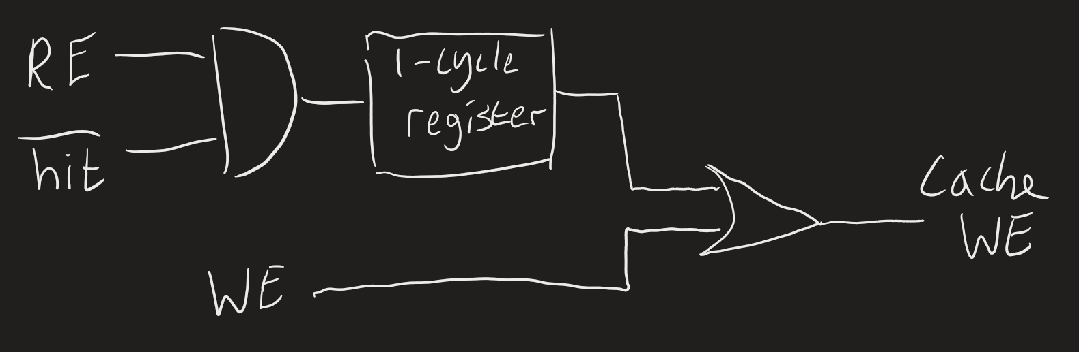

Figure X: Logic diagram for Write Enable.

Regardless of whether there is a hit or miss, when the uP sends a write enable, we want it to get immediately sent to the Cache Data block, which you can see in the top circuit. When the uP sends a read enable and it’s a miss, we must wait a cycle for the data to be retrieved from the RAM, and then we write that data to the Cache Data block.

**Done Signal Logic:**

There are 4 operations the cache is capable of: Read Hit, Read Miss, Write Hit, and Write Miss, as explained in the General Implementation section. These each have a latency of 2, 3, 2, and 3 cycles, respectively. The Done Logic reflects these cycle delays according to the logic below:

**Figure X:** Logic diagram for Done Logic.

Notice that each operation has reset logic. Since the enables and hit logic are asserted for the duration of the operation, we must clear the done signal ourselves by activating the reset in all the registers the cycle after.

**Cache Data Block Logic:**

This logic is just a mux that switches between the data input from the uP (when WE high) or from the RAM (when WE low) as the data input to the Cache Data block.

**Data Output Logic:**

This logic determines what data is put on the data output port of the cache. If we're not doing a read, set the data output to all 0’s. If we are doing a read and it's a hit, direct the data directly from the cache. If we are doing a read and it's a miss, send the data from the RAM. The output data is then registered and only outputs when done is asserted, otherwise, it is all 0’s.

#### Simulation Results

The Cache Control block testbench consists of a set of 1000 random testcases w:

We performed 1000 total randomized testcases with different constraints on their signals:

Test 1 (100 repetitions): Neither read nor write enable are ever asseith the following constraintsrted to test that the LRU buffer should only ever update when the enables are asserted. The way and index inputs are randomized according to the global constraints listed below.

Test 2 (100 repetitions): Read enable is asserted every cycle, write enable is never asserted. The way and index inputs are randomized as in test 1.

Test 3 (100 repetitions): Same as test 2 but replace read enable with write enable.

Test 4 (700 repetitions): All inputs are randomized with the constraint that the or of read enable and write enable is high only 50% of the time to keep the frequency of updates and non-updates even.

**Constraints:**

* **we_re:** Write enable and Read enable can never both be asserted at the same time.
* **Data_in_range, data_from_cache_range, data_from_RAM_range, way_range:** WriteThese inputs have the following distribution independent of each other: ‘0 10% of the time, ‘1 10% of the time, the rest of the range 80% of the time.

**Figure X:** Randomized tests for Cache LRU Buffer.

As you can see in the randomized tests, in Test 1, both RE and WE are 0, so the LRU buffer for index 3 stays 0, 1, 2, 3. In Test 2, way 1 for index 1 is chosen and WE is high, therefore way 1 is put at the end of the LRU buffer and the remaining ways move up one slot. Tests 3 and 4 see the same behavior but for index 2 and with different combinations of RE and WE. In Test 4 repetiton 2, the previous buffer state for index 1 was 0, 2, 3, 1, and this test calls for way 2 of index 1 to be used, so way 2 gets sent to the end of the buffer and the rest of the ways update accordingly for a buffer state of: 0, 3, 1, 2.

The bottom output reports the number of tests, failures, and randomization failures. This is meant to show that the CRV is constraining the inputs how we expect it to and the test is passing with 0 errors.

**Assertions:**

* **LRU_check:** This assertion makes sure that the least recently used slot points to the same bank as the timer mentioned above for all indices concurrently.
* **No_update:** This assertion checks the LRU buffer for each index does not update when read enable and write enable are not asserted

## Ram Block

### Functionality

The RAM block is implemented as a DEPTH-long WIDTH-bit array of memory/register locations. The RAM takes in an address, data, and a write enable as inputs, and its only output is a WIDTH-bit data output. Both RAM reads and writes are synchronous, only updating the contents of the ram on a cycle where the write enable is asserted. Reads are only valid a cycle after write enable is not asserted.

### Simulation Results

The RAM testbench consists of a set of direct testcases and random testcases.

**Directed Testcases:**

In the directed testcases, we set the address and data input to the incrementing test number, set the write enable to 1, and wait for the rising edge of the clock (ex. Testcase 2 has addr=2, data_in=2, we=1). We do this for every address in the RAM. The testbench itself has a reference model that mimics the behavior of the RAM in an array. After all addresses have been written, we then read from every address and compare with the data saved in the same addresses of the reference model. This testcase ensures that data that is written to RAM is maintained over longer periods of time, even as other addresses are written to and read from. See the figure below to see the first 5 values written to and read from the RAM.

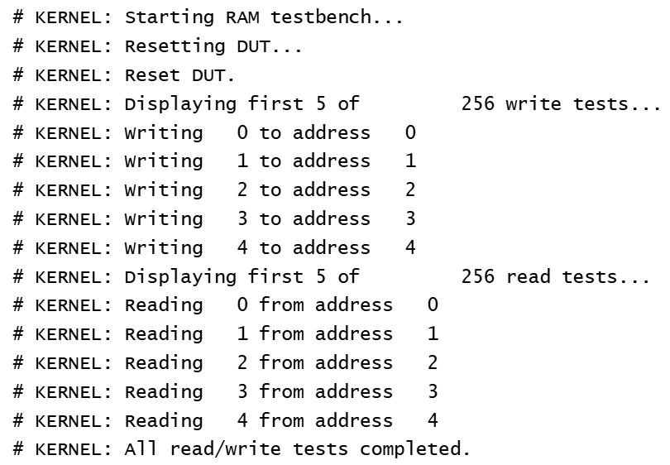

**Figure X:** Directed tests for the RAM.

**Random Testcases:**

We performed 1000 random test cases with the following constrained random verification:

* Data input is all 0s 10% of the time, all 1s 10% of the time, and the rest of the values the other 80% of the time.
* Address input follows the same constraints as the data inputs.
* The write enable is asserted 50% of the time for 50% reads and 50% writes.
* Writes are followed by reads which must use the same address used for the write so that each write to a random address is checked.

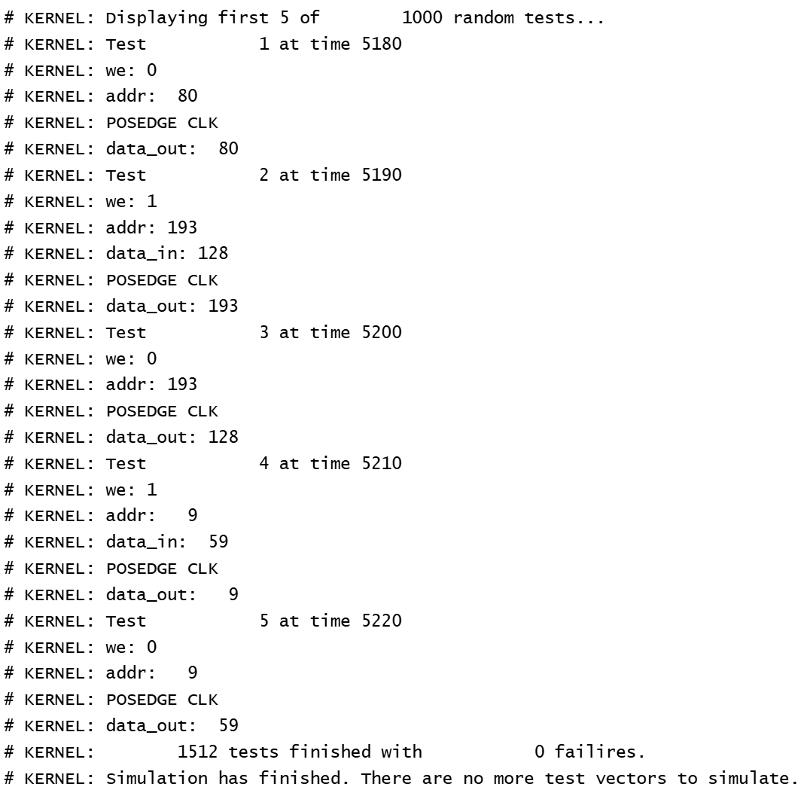

**Figure X:** First 5 random testcases for the RAM block.

In this testcase, we can see that a read from address 80 returns 80, which was the value written to that address in the directed testcase. The next operation is a write of 128 to address 193, and we can see in the next operation, which is a read from address 193, that the data out is 128, and so the data was saved correctly. The next 2 testcases exhibit the same behavior for address 9 with the data value 59.

**Assertions:**

* **out_correct_check:** On a read/when the write enable is de-asserted, data output is equal to the data found in the reference model using the same address.
* **write_check:** When the write enable is asserted and followed by a read, and the address is the same for the read as for the write, then we wait a cycle for the read to happen and check that the input for the write was the data output for the read.

## Miscellaneous Logic

### Register

#### Functionality

The register entity is a standard register with a WIDTH-bit input and output with no enable.

#### Simulation Results

To test the register, we first did a set of directed tests where we assigned an 8-bit register each possible value from 0 to 255. See the figure below for the first 5 directed tests. We also did a set of 1000 randomized tests, with the data inputs being constrained to all 0s 10% of the time, all 1s 10% of the time, and all values in-between for the remaining 80% of the time.

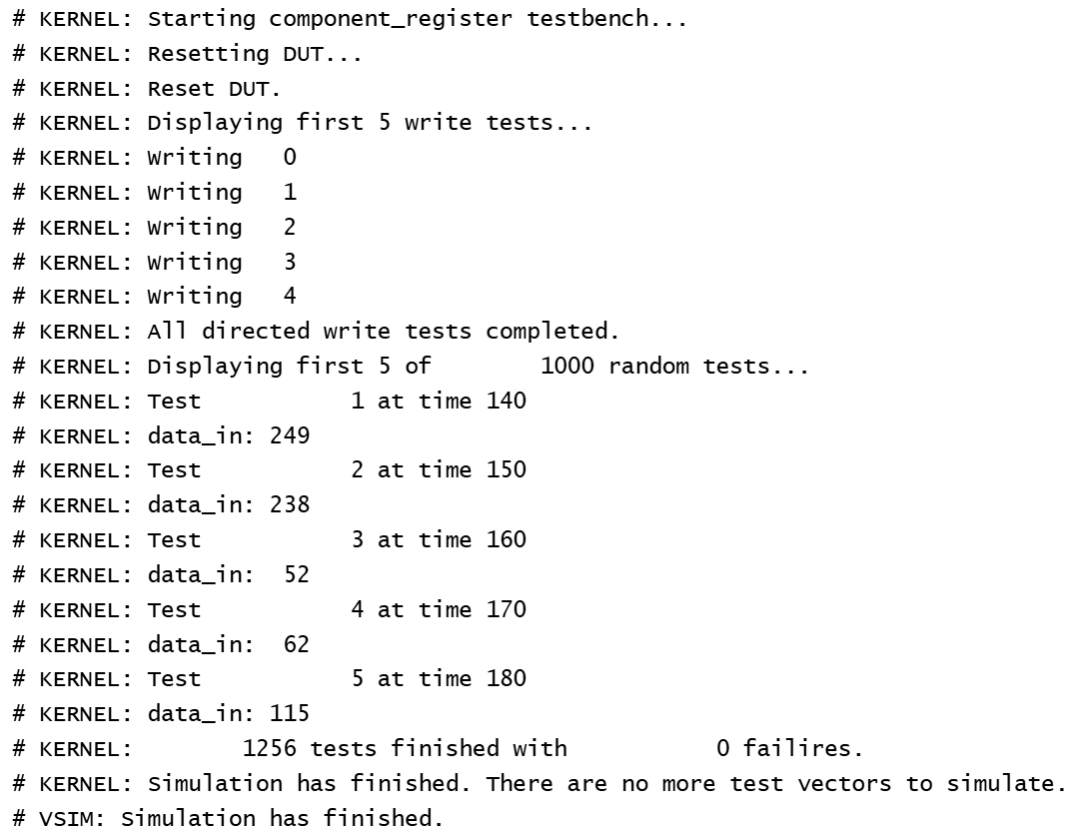

**Figure X:** Testbench results for the register component.

**Assertions:**

The assertions for this testbench are just checking that on each clock, the data output from the register is the data that was on the input line in the previous cycle.

### Delay

#### Functionality

The delay entity is a CYCLE-long array of WIDTH-bit register components.

#### Simulation Results

The delay testbench is similar to the register testbench since the delay component is just a string of registers. We did the same directed tests from 0 to 255 and the same set of 1000 randomized tests, with the data inputs being constrained the same way.

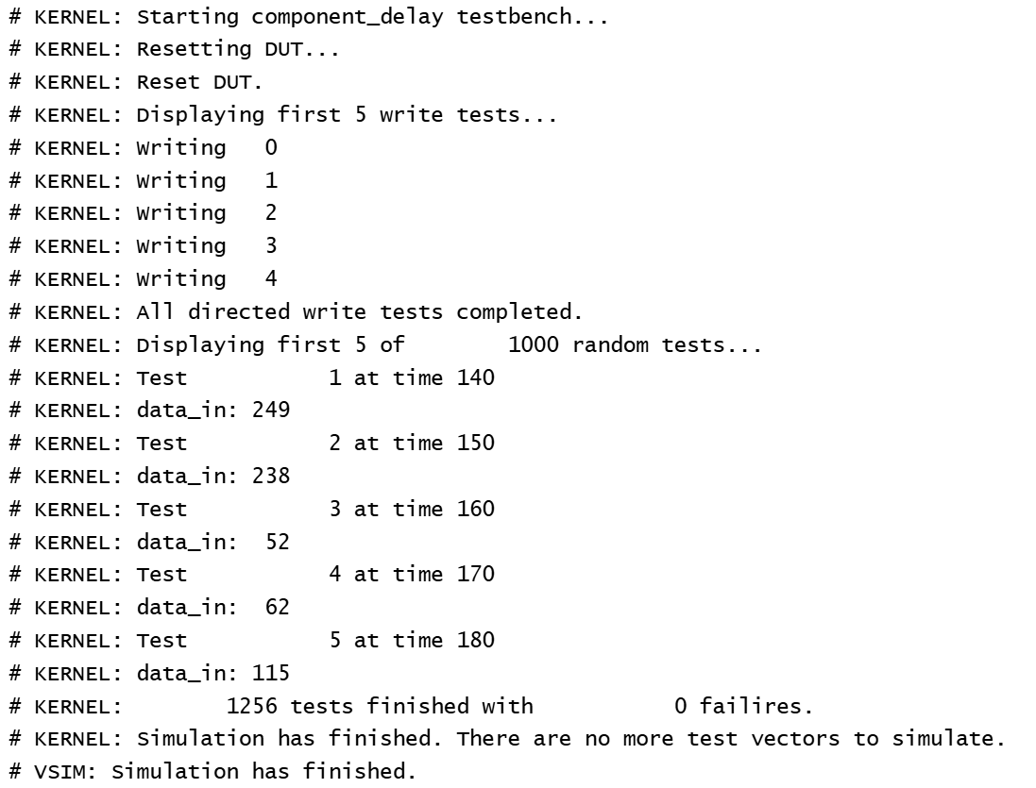

**Figure X:** Testbench results for the delay component.

**Assertions:**

The assertions for this testbench are similar to the register testbench’s checking that on each clock, the data output from the register is the data that was on the input line in the previous number of cycles specified by the length of the delay, which is 4 cycles in this testbench.

# Conclusion

This was a fun and challenging project. During this project, we learned that it’s much easier to implement a design by first very clearly specifying the functionality and ONLY then implementing it in code. This is how it’s done in the industry, but we underplayed the complexity of the design and thought we could jump straight into the implementation. Since we realized we would have to go back and define the exact functionality, the design got confusing and we only started making progress once everything was set in stone.

This project was both a good practice of our understanding of caches/the algorithms that help them work and of hardware design/verification.